**REPORT OF OUR ADVANCED JAVAPROGRAMMING PROJECT**

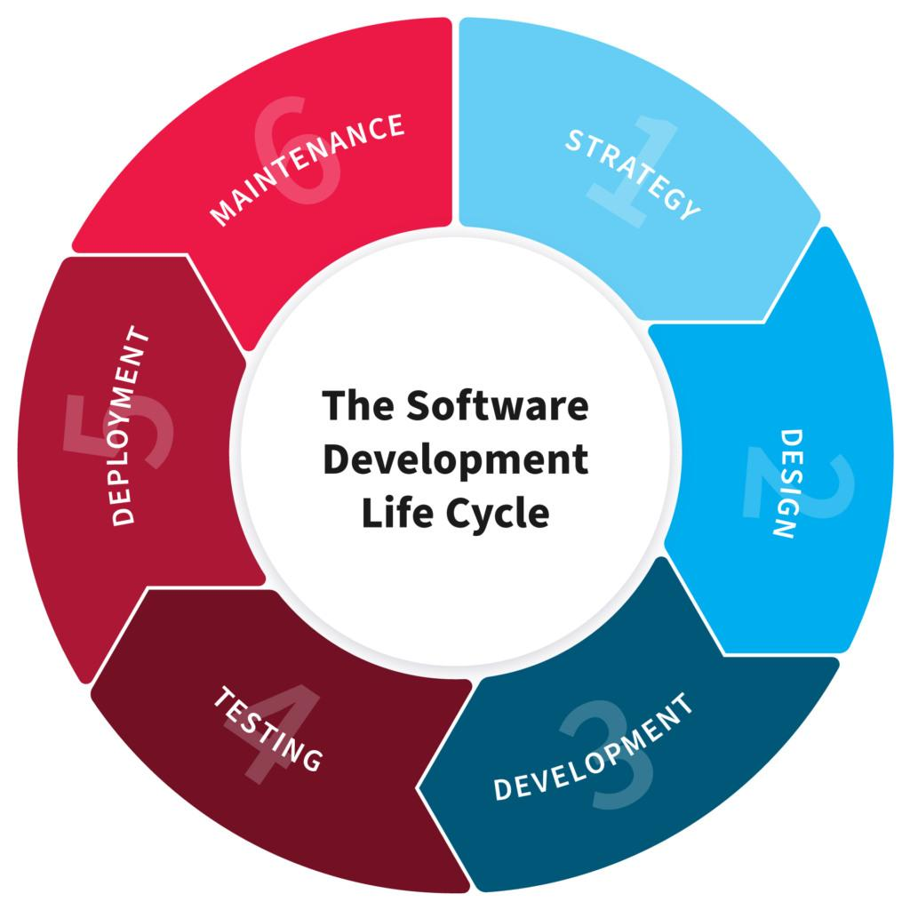

**NAME:** **MUSHABE Fred**

**REG NO: 221019397**

**CLASS NO: 56**

**PROJECT NAME: SMART CITY GUIDE**

**1. PLANNING**

*“In this Section, Students, have to define the system (your projects) goals and objectives and the problems the future system needs to solve.”*

**Introduction**

**Smart city guide:** this is a web based software system that shaped up with two using modes which are user mode and admin mode.

It is built to store information regarding to locations facilities address that help users to be guided according to information given about essential city features like hospital, church, school, hotels, restaurant etc…which is useful for today’s technology based, in addition this system help to get detailed data like website, contact and address of certain feature the user searched for.

**Goal and objectives**

The main goal of smart city guide is help users of the system getting all information and guidance about city components. This means you can know how many churches hospitals, school, restaurant, hotel, market etc… around you and what category are they on.

Moreover smart city guide’s objective is to help government in being informed about locations statistics how many hotels, restaurants, hospital according to their category and capacity so that can be based on for country budgeting, improvement, tax collection and good governance.

It would be helpful by creating an integrated platform to store essential and related information to guide newcomers in a city, tourist, student and parent searching for school etc... As is a web-based product used to store the details of particular city and helps all the users who just visits our system

**Problem system needs to solve**

It is not easy to have information about public and private facilities around you,

For example it hard to get information about how many schools are in certain location like Huye, at which category it belongs to which can help new comers in city to choose best school for their children to study. The same to other facilities like church, hotel, restaurant, market etc… not easy to have detailed data about.

The person who are visiting a particular city need to gather information from the person who is staying in the city or take the help of the guide in the city. Gather of all these information you need to visit the city. This possesses a lot of time and pre-planning. In order to get each piece of information we need to go for help desk instead of observing all essential information about the place he/she wants to visit, before reaching and deciding to be there.

Business entities cannot know how many competitors I can be having when I open supermarket in city because exact number of supermarkets are operating in city

Briefly this system would be great answer for all mentioned above problems and other relating problems I have not mentioned.

**2. Design**

*“In this Section, student’s needs to elaborate how the system will work, focusing on software design and how it works with the technical and functional requirements of the system. Depicts also how your team defined how users will interact with the software.”*

As introduced it before this system would be in two different modes, the user mode and admin mode that will be mandatory to choose one

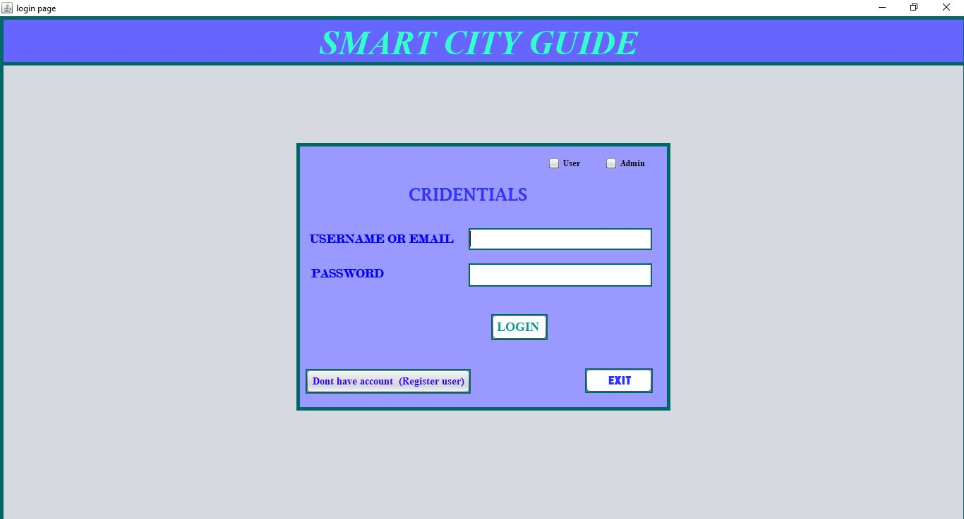

If the user has no account can make register on system but not the same to admin the admin is registered by another current admin in database.

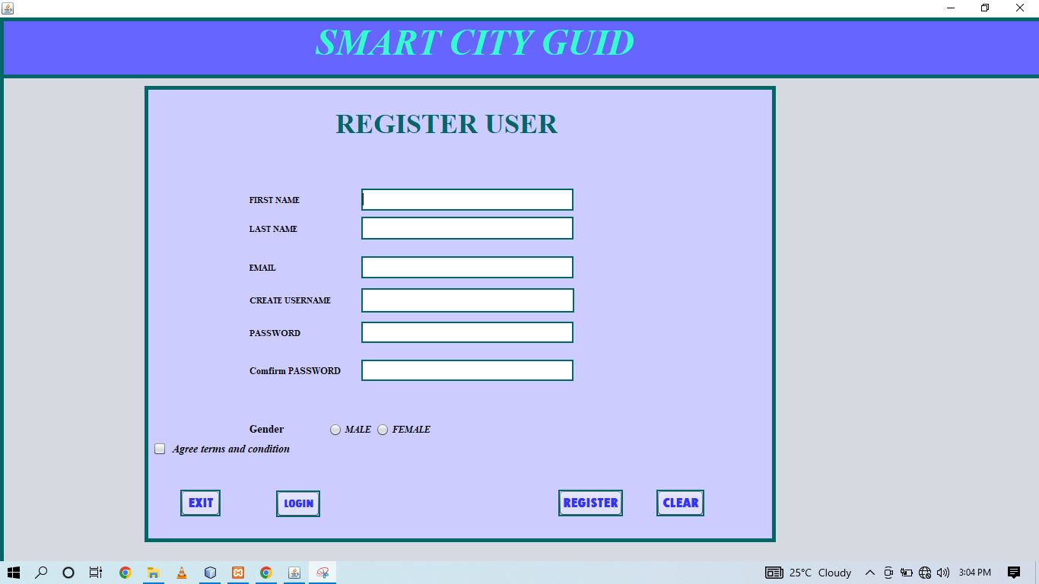

**2.1 Users of the System**

* **User Mode:** This user can betourists, students, Businessmen, Industrialists, Entrepreneur, Organizations academicians, Jobseeker and all users that are searching for information.

**THE USER HOME PAGE**

After login the user should have this interface

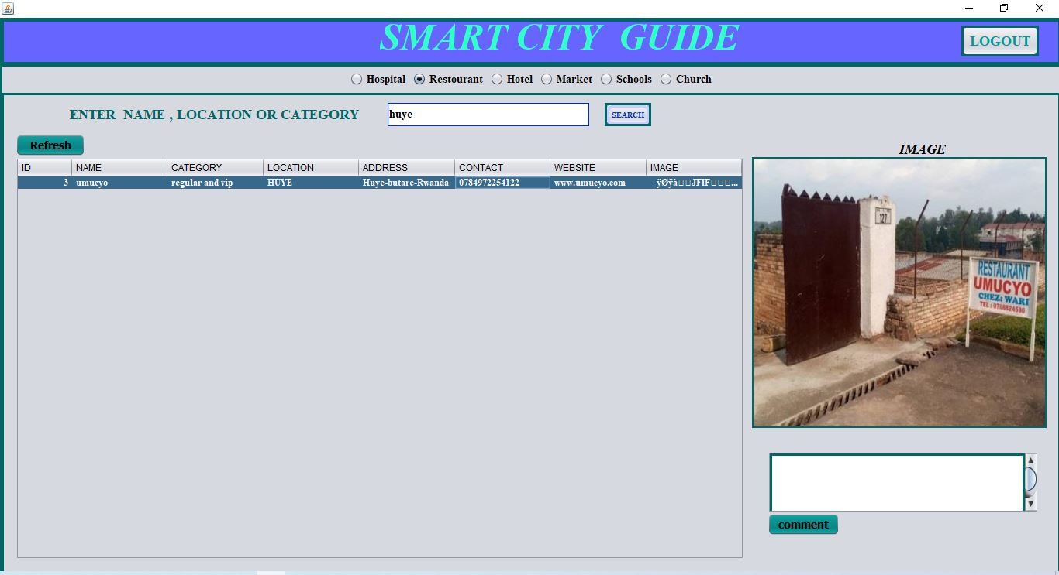

* **Admin (administrator)mode:** The administrator is responsible for adding information, deleting information updating information, viewing city all information and comments checking

**THE ADIMINISTRATOR HOME PAGE**

After login the admin should have this interface

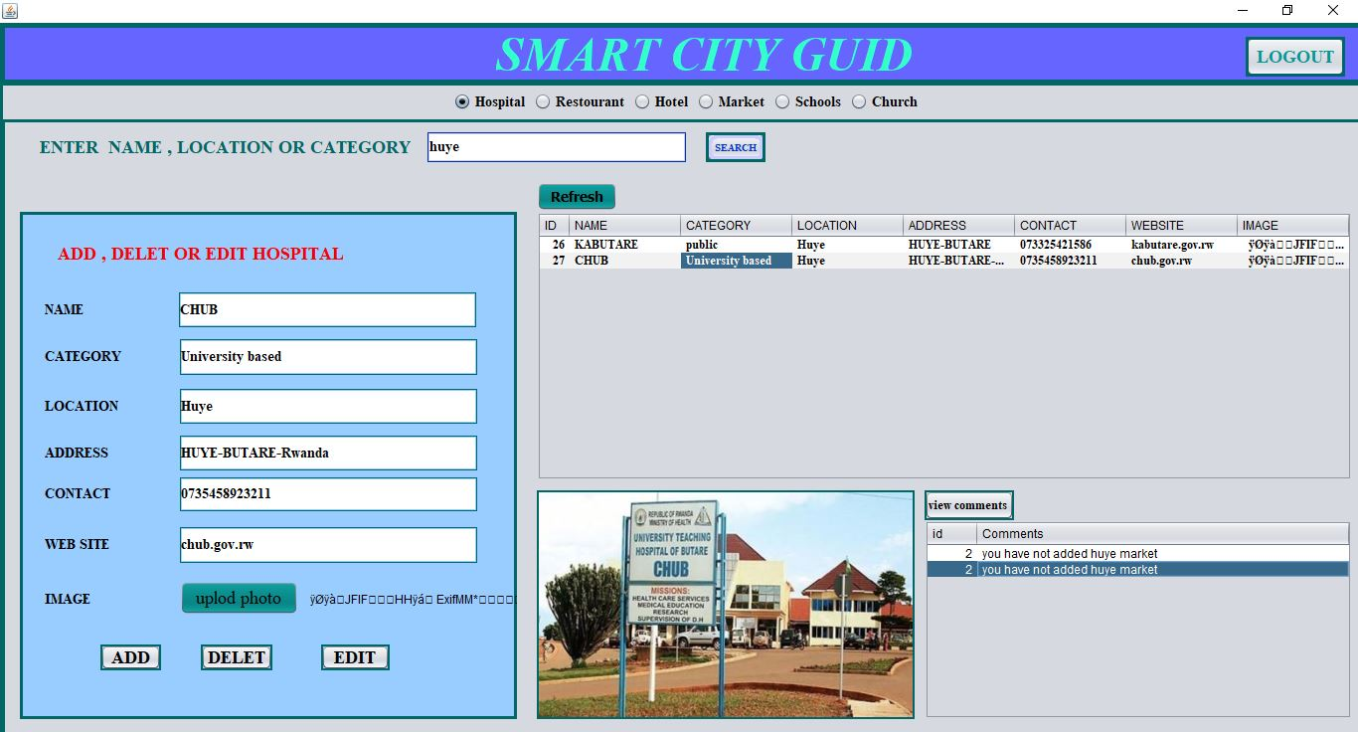

**2.2. Specific Requirements**

**Functional and Non Functional Requirements**

**Functional Requirements of the system:**

* Secure registration of all users
* Login
* logout
* Complete Search of the entire city for easy access.
* Adding, deleting and updating system information.
* Local language support at user-interface and database-level.
* Complete overview of the Businesses in the city.
* Registration of city facilities (school, hospital etc…) with image uploaded.
* Facilitate communication between user, of the system and administrator through comment for enhancement and error correction

**Non-Functional Requirements of the system:**

* Available all time
* user-friendly
* Flexible service based architecture will be highly desirable for future extension.
* Scalability: capacity of serving big number of users at same time and use short time

**2.3 DESIGN**

**2.3.1 DFD LEVEL 0**

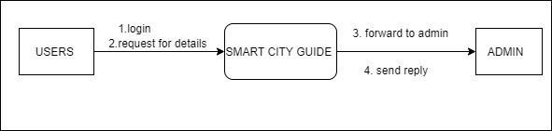

**2.3.2 USE CASE DIAGRAM**

This use case diagram describe how system works, functional requirements and activity each can perform

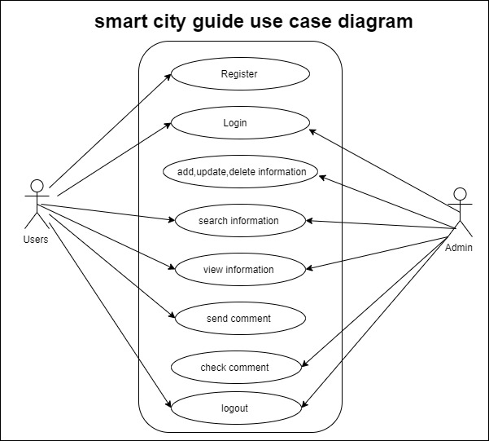

**3. DEVELOPMENT**

*“In this Section, Students need to elaborate how they build the entire system( Front end- back end technologies), chosen libraries, platforms, storage and databases, adopted technologies, etc...”*

* Download jdk19, NetBeans IDE, mysql connector and xampp and installed each before start of shaping our project.
* We developed the system backend and frontend parts using java programming language as well as NetBeans IDE and xampp for database.
* For frontend parts, we used swing controls generated from NetBeans to create forms, buttons, labels as well as user interface as whole.
* We used MySQL as database management system to hold backend data.
* We create interactions between user interface components such as forms and buttons using java programming language syntaxes.
* We used com.mysql.jdbc_5.1.5.jar as library handling MYSQL connection with the system and also absolute layout.jar.

**4. TESTING**

*“In this Section, Students to show the way this stage was conducted. Ensuring that everything works as expected. Which defects and bugs you found, and how did you fixed them to ensure that the product meets the original specifications.”*

This testing period is more complex that’s the stage of knowing whether your system gives output or not so being careful is best advice.

In testing of our project we first used debug and many errors was in our project

* The first error was the system is not connected to database this was showed by the time we was trying to enter login data for user to access user home page

To solve this error we imported



In project library in order to help connecting to mysql database.

**THE TABLE BELLOW SHOW SOME TESTING WE DID IN ORDER TO MAKE SURE OUR SYSTEM IS WORKING AS HOW WE WANT IT**

|  |  |  |  |  |  |  |
| --- | --- | --- | --- | --- | --- | --- |
| Testing part | Test Case Name | Input | Expected Output | | Actual Output | description |
| **login** | Skipping user mode selection | Skipping user mode selection | Choose mode first  User or admin | | Choose mode first  User or admin | You must choose mode |
| Entering invalid username and password | Fred123 | User name or password is incorrect | | User name or password is incorrect | Enter valid username or email and password  That correspond to database data |
| **Register user** | First name& last name | * fr * fr123 | | Name should be greater than 2 alphabet and also name should not contain number | Names entered is invalid | Invalid |
| First name& last name | * mushabe * fred | | Name should be greater than 2 alphabet and also name should not contain number | Valid name | Registration will be success if all conditions to register form is performed well |
| Email | fredmushabe | | Email should in form of xxxx@xxx.xxx | Email should in form of xxxx@xxx.xxx | Make  Registration will be success if all conditions to register form is performed well |
| email | * mushabe@gmail.com | | Valid email | Valid email | Registration will be success if all conditions to register form is performed well |

Some example of testing pictures

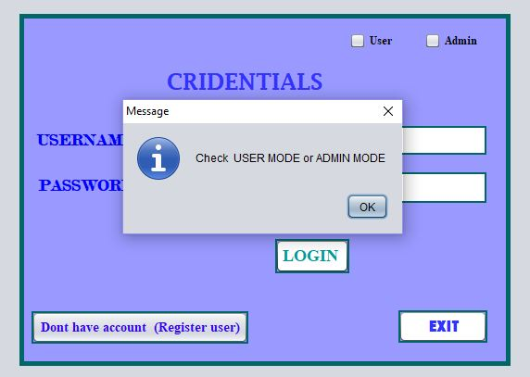 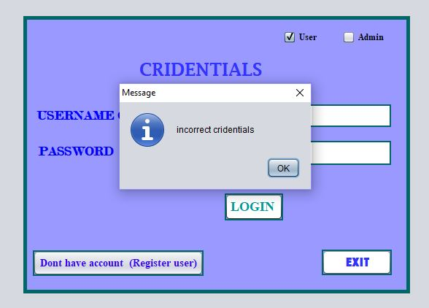

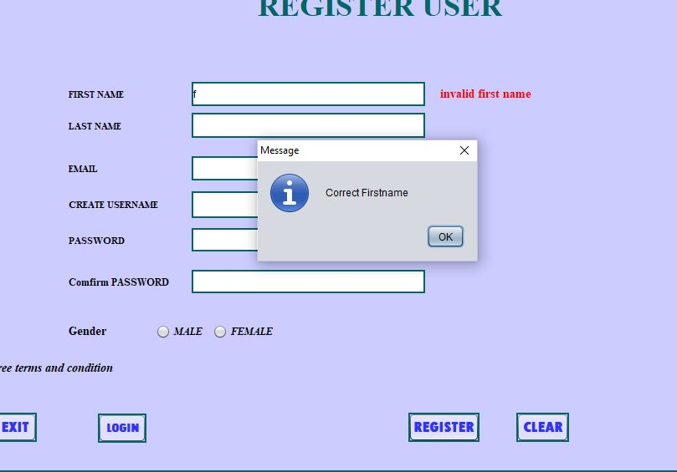

After testing all requirements is performing in login and registration

* We logged in as admin and tried to add any school in our system in addition if we tried to upload school image the message was image is lager

By using Microsoft picture manager we compressed photo to 58kb and upload the school was added successfully

* We used the user mode to try searching school we added by admin and it was viewed by entering huye as location in search box
* We also the user mode to try searching school we added by admin and it was viewed by entering name of school in search box

Our testing concluded by commenting using user mode and view comment in admin mode which was done successfully

All activities are operating 100% and it is ready to be used

**5. DEPLOYMENT**

*“In this Section, Students have to describe how, installation, testing, deployment, and performance monitoring were conducted in their own respective laptop or desktop. “*

In the DEPLOYMENT of this project after installation, testing;

* We used portable storage device to transfer project from development computer to the user who want to explore application.
* We downloaded and installed Xampp to configure MYSQL as database management system on the next computer
* We Downloaded and configured com.mysql.jdbc_5.1.5.jar as library handling MYSQL connection.
* Use portable storage device to transfer project from development computer to the user who want to explore application.
* We tested my city guide by entering wrong data to see if it won’t work and by entering right data to see if it will work well.
* The speed of system is faster and is well connected to database
* After debugging, testing and correcting errors I Run project file and start using the system

That was all about each step we conducted in this journey of building this project however it can be enhanced according to technology extends

Thank you for caring and reading this content you’re free to add your comment about this project do you think would be better solution as it is our opinion

Contact [fredmushabe20@gmail.com](mailto:fredmushabe20@gmail.com) for more information or advise to what you have seen that can be improved.